**HANDS-ON Day 2: GIT COMMANDS**

***GIT COMMANDS***

***1.git --version***

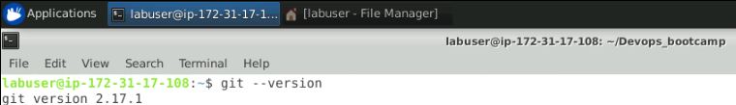

***2.git config --global user.name = "your name"***

***3.git config --global user.email = "your email"***

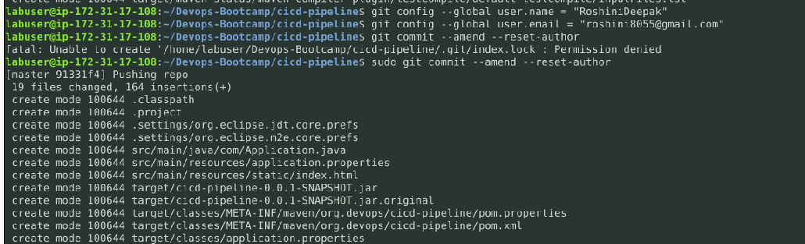

***CREATING A GIT REPOSITORY***

***1.mkdir <directory name>***

***2.cd <directory name>***

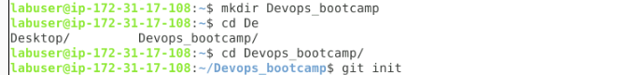

***3.git init - converts a directory into a git repository***

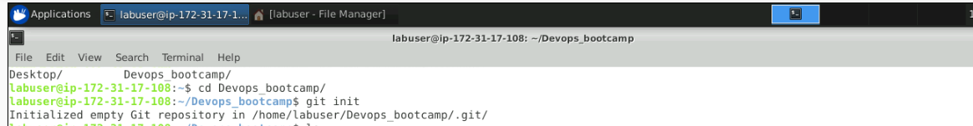

***4.git add fileName or git add .***

***5.git commit -m "commit message"***

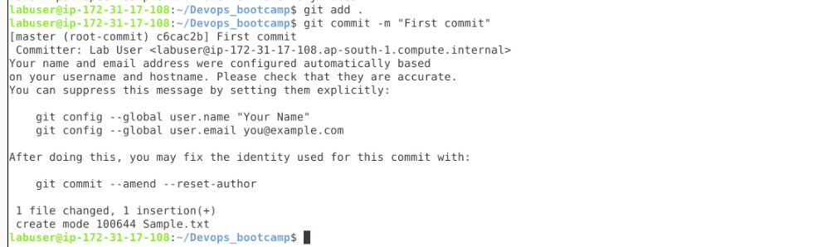

***6.git status***

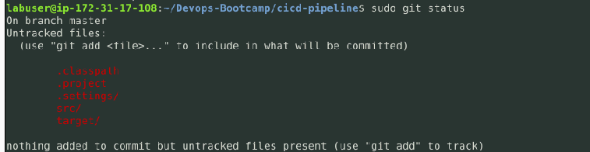

***CONNECTING AND ADDING A REMOTE REPOSITORY***

***1.git remote add origin <ssh url>***

***2.git clone <repo name>***

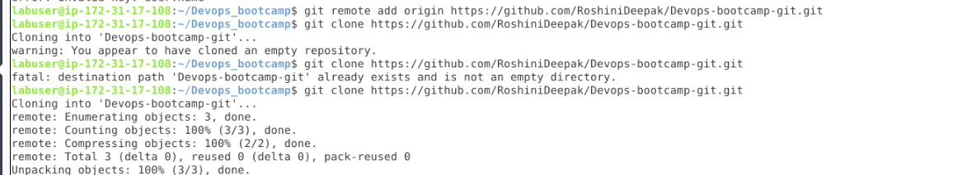

***3.git pull origin master***

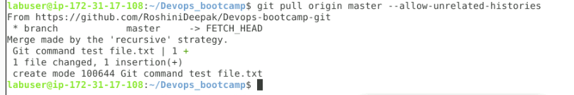

***4.git push origin master***

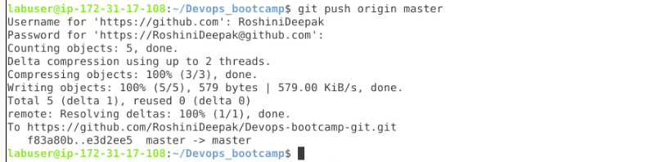

***BRANCHING COMMANDS***

***1.git branch***

***2.git branch $branchName***

***3.git branch -d $branchName***

***4.git merge $branchName***

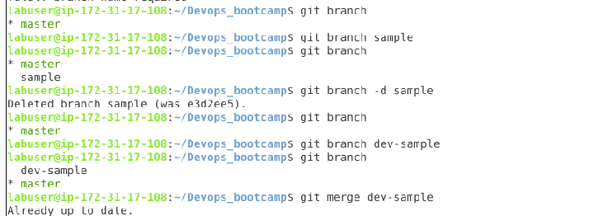

***ADVANCE GIT COMMANDS***

***1.git stash***

***2.git stash -u***

***3.git stash list***

***4.git stash apply***

***5.git log***

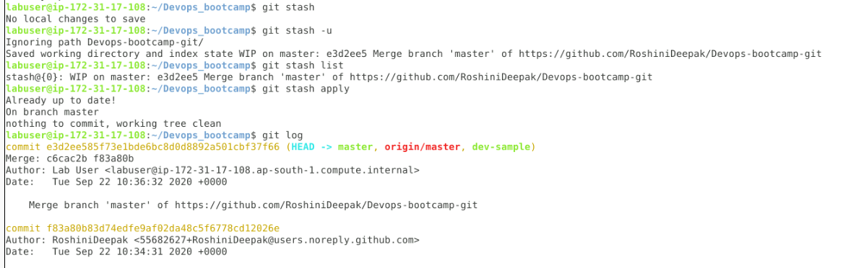

**6.git rebase**

**7.git revert**

